Edgar J. González Serrano

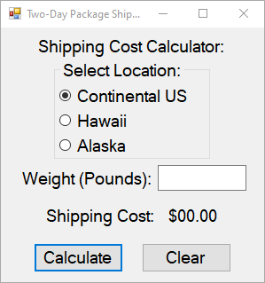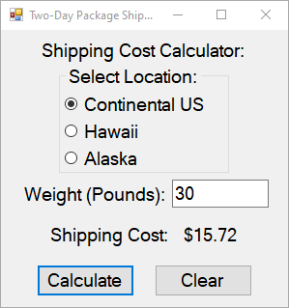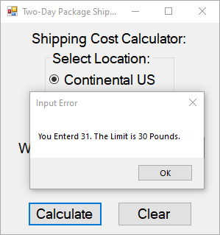

Public Class Form1

Private Sub Bclear_Click(sender As Object, e As EventArgs) Handles Bclear.Click

Me.MainlandUSButton.Checked = True

Me.AlaskaButton.Checked = False

Me.HawaiiButton.Checked = False

Me.PoundsBox.Text = ""

Me.Cost.Text = "$00.00"

Me.PoundsBox.Focus()

End Sub

Private Sub Calculate_Click(sender As Object, e As EventArgs) Handles Calculate.Click

Dim decBox As Decimal

Const ALselect As Decimal = 0.26

Dim total As Decimal

Const Haselect As Decimal = 0.2

Dim p2 As Decimal = 3.69D

Dim p4 As Decimal = 4.86D

Dim p6 As Decimal = 5.63D

Dim p8 As Decimal = 5.98D

Dim p10 As Decimal = 6.28D

Dim p30 As Decimal = 15.72D

If IsNumeric(Me.PoundsBox.Text) Then

decBox = Convert.ToDecimal(Me.PoundsBox.Text)

If decBox > 0 Then

If Me.MainlandUSButton.Checked Then

If decBox <= 2 Then

Me.Cost.Text = p2.ToString("C")

ElseIf decBox <= 4 Then

Me.Cost.Text = p4.ToString("C")

ElseIf decBox <= 6 Then

Me.Cost.Text = p6.ToString("C")

ElseIf decBox <= 8 Then

Me.Cost.Text = p8.ToString("C")

ElseIf decBox <= 10 Then

Me.Cost.Text = p10.ToString("C")

ElseIf decBox <= 30 Then

Me.Cost.Text = p30.ToString("C")

ElseIf decBox > 30 Then

MsgBox("You Enterd " & decBox & ". The Limit is 30 Pounds.",, "Input Error")

End If

ElseIf Me.AlaskaButton.Checked Then

If decBox <= 2 Then

total = p2 * ALselect

total = total + p2

Me.Cost.Text = total.ToString("C")

ElseIf decBox <= 4 Then

total = p4 * ALselect

total = total + p4

Me.Cost.Text = total.ToString("C")

ElseIf decBox <= 6 Then

total = p6 * ALselect

total = total + p6

Me.Cost.Text = total.ToString("C")

ElseIf decBox <= 8 Then

total = p8 * ALselect

total = total + p8

Me.Cost.Text = total.ToString("C")

ElseIf decBox <= 10 Then

total = p10 * ALselect

total = total + p10

Me.Cost.Text = total.ToString("C")

ElseIf decBox <= 30 Then

total = p30 * ALselect

total = total + p30

Me.Cost.Text = total.ToString("C")

ElseIf decBox > 30 Then

MsgBox("You Enterd " & decBox & ". The Limit is 30 Pounds.",, "Input Error")

End If

ElseIf Me.HawaiiButton.Checked Then

If decBox <= 2 Then

total = p2 * Haselect

total = total + p2

Me.Cost.Text = total.ToString("C")

ElseIf decBox <= 4 Then

total = p4 * Haselect

total = total + p4

Me.Cost.Text = total.ToString("C")

ElseIf decBox <= 6 Then

total = p6 * Haselect

total = total + p6

Me.Cost.Text = total.ToString("C")

ElseIf decBox <= 8 Then

total = p8 * Haselect

total = total + p8

Me.Cost.Text = total.ToString("C")

ElseIf decBox <= 10 Then

total = p10 * Haselect

total = total + p10

Me.Cost.Text = total.ToString("C")

ElseIf decBox <= 30 Then

total = p30 * Haselect

total = total + p30

Me.Cost.Text = total.ToString("C")

ElseIf decBox > 30 Then

MsgBox("You Enterd " & decBox & ". The Limit is 30 Pounds.",, "Input Error")

End If

End If

End If

Else

MsgBox("You Enterd a invalid input. Write a Number",, "Input Error")

End If

End Sub

End Class